C.E.N.S. Applications - Examples:

C.E.N.S. has a wide range of uses. Here we provide a very brief description of typical examples that may echo your own needs. In each case the generic architecture is similar, but the specific implementation is tailored to the business needs of the client.

1) Maintenance monitoring and planning

A group of sensors in-plant and remote field sensors stream data to a line engineer, a supervisor and a planning manager.
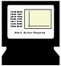
Line engineer controls feedback response to sensed activity


Local data node

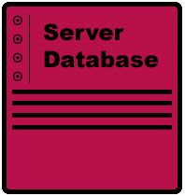
Server database

Supervisor oversees compliance with control procedures

Remote data node

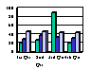
Planning manager analyses histories and organises efficient resource use and audit

2) Retail monitoring

A city centre manager, private retailers and local authority use sensed data on pedestrian footfall and traffic monitoring for different purposes.

City Centre Manager uses data for estates management and promotional planning
Server database



Individual retailers use data for supply scheduling and marketing review

Multiple sensors gather data on pedestrians and vehicle traffic, passing multiple streams to the analysis database
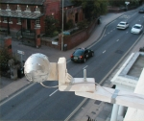
Local authority uses data for movement and access needs & infrastructure plans

Server database
Multiple sensors gather data on pedestrians and vehicle traffic, passing multiple streams to the analysis database
City Centre Manager uses data for estates management and promotional planning
Individual retailers use data for supply scheduling and marketing review
Local authority uses data for movement and access needs & infrastructure plans

3) Industrial monitoring

An industrial plant practising just-in-time resource planning co-ordinates production schedules, logistics and resource planning. Audit and review is implicit in the data set gathered through C.E.N.S.


Enterprise Server

C.E.N.S. Server


Sensed data collects inputs, audits performance during line processes and captures outputs. Parameters are streamed to C.E.N.S. database which is integrated with other data systems.
Logistics and production planning enhanced by combining C.E.N.S. with ERP systems.
Quality managers obtain good fit to target process compliance
Procurement management uses data to improve just-in-time performance

4) Field monitoring

An environmental authority gathers data across a floodplain and a city centre from various key points. Data parameters are displayed on the area maps in an easy to read form.
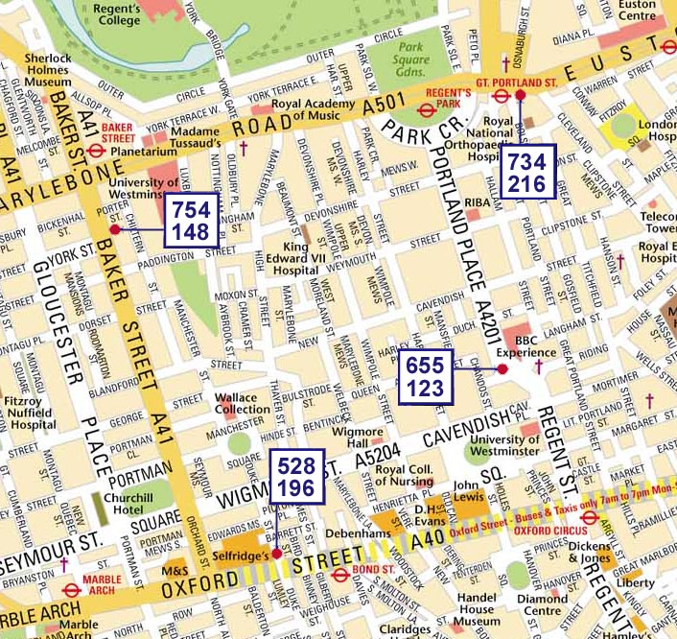
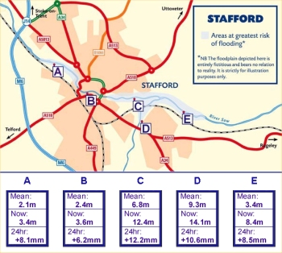

Screen array displays discrete points of interest with multiple watercourse parameters showing change through time
On map overlays showing point values of key pollution measures to provide an area wide picture of particulates and carbon monoxide

5) Medical (roaming) monitoring

A patient with high blood pressure is monitored through the day in his local area. This application uses GPRS mobile technology. Status monitoring, intervention thresholds and feedback alerts are all relevant here to maintain patient compliance and oversight.

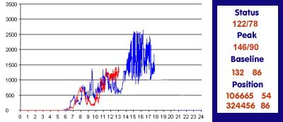
Server database

Real-time plots allow instant visibility of patterns of action and result. Data is also streamed to a database for history and analysis.
Mission critical parameters monitored in real time. Data averages or thresholds used to trigger response alerts.
Multi-level monitoring by staff with differing skill levels allows maximum productivity.

Special purpose monitoring

A specific need is discovered and a C.E.N.S. solution adopted. By placing software and processing next to the analysis point C.E.N.S technology extracts the maximum information from sensor data with the minimum of bandwidth overhead.


In-vehicle sensors and processors

Bandwidth minimised – only value adding data sent to server

Server database
Java engine

Live streaming
Java clients provide structured data, video, audio, graphs
Data thinning.
Only relevant data is sent to the network Computing power and processing
is done where it is needed

Alerts and feedback response
where value is provided

To find out more:

Main Highway – C.E.N.S Team
39 Southgate Street
Winchester SO23 9EH

Tel: 01962 870680 Fax: 01962 870699
E-mail: catseye@mainhighway.com
Web: www.mainhighway.com/catseye

