Networking
Overview

C.E.N.S. Networks Architecture

Cats Eye Networks (CENS) have developed a sensed data streaming solution that can capture data from almost any analogue or digital device and stream it to any number of users through desktop internet browsers. The technology is powerful, secure, real-time, always on and can be customised for a wide range of sensing needs including two-way feedback solutions.

Sensed data and feedback response

A C.E.N.S. network can measure any parameter for which a sensor device exists. We can link our equipment to analogue, digital or operator activated signals. We can also link to actuating devices to enable back loop response functions. We can help you choose the best sensing solution through our wide range of partners in the sensing and automation industries. Our business is streaming your data in a way that adds value by providing enhanced control, response and compliance and audit opportunities.

Network Architectures

Our solution can be configured in many ways depending on whether you are capturing your data from locations with an existing local information technology infrastructure or locations in the field. The general architecture is illustrated below:
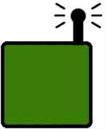
Internet access point

Internet
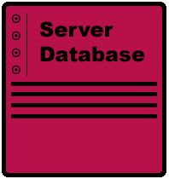
Server database
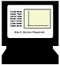
Browser viewers
Closed user group
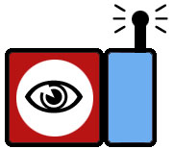
Local Sensors

The links in this chain can be wireless or landline enabled depending on need. The data is streamed from single or multiple sensors. It is delivered through standard internet browsers to pre-defined closed user groups stratified by secure log-in technology. This allows different data summaries to be presented to operatives, line managers or planning staff.

Multi-point to multi-user solutions

By extending the architecture we are able to provide multiple data streams that relay comparative data from multiple locations. Sensor communities can therefore be configured to allow a multi-sensor multi-user service that can be charged by access subscription.


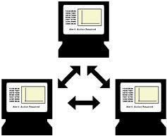
User group viewers
Server database
Internet

Local data node

Sensor cluster

Software architecture

The streaming of real-time data from a sensor point via a server to an internet browser is not a simple matter of joining the elements together. Cats Eye Networks have a proprietary suite of software tools which enable us to control, analyse and stream data in a way that is practical, flexible and commercially viable. The basis of the technology is a series of Java modules that store analyse and forward data through the C.E.N.S. network. Java servlets put computing power where it is required within any particular network – delivered by our server Java engine.
Server database
Java engine

Computing power and processing
is done where it is needed
Alerts and feedback response
where value is provided

Local Sensors
Data thinning.
Only relevant data is sent to the network
Internet access point

Local event handling
Some alerts of event calls can be sent back to sensors from here.
User group viewers
Live streaming
Java clients provide structured data, video, audio, graphs
Local data node

Data selection
Structured data sent to the network

By placing software and processing throughout the network we are able to extract the maximum information from your sensor streams with the minimum of bandwidth overhead. Various other techniques enable us to maximise the transmission of aggregated values while retaining the ability to collect audit histories.

The result is a cost-efficient sensed data network tailored to your needs and delivering structured and relevant information directly to the desktop of those who need to know.

To find out more:

Main Highway – C.E.N.S Team
39 Southgate Street
Winchester SO23 9EH

Tel: 01962 870680

Fax: 01962 870699
E-mail: catseye@mainhighway.com
Web: www.mainhighway.com/catseye

