Footfall
Measurement

C.E.N.S. and Footfall Measurement

The measurement of pedestrian footfall has become increasingly important to retailers, supply chain managers and planning authorities. Knowledge of patterns and quantities in customer movement allows retailers to be sure that expensive investment in distribution, merchandising and promotion is providing the results they need.

Capturing Footfall Data

The C.E.N.S. footfall solution offers highly accurate data gathering both indoors and outdoors. We can provide both pattern recognition methods using video technology and a simpler infrared detection solution for more controlled footfall situations. We will help you choose the best sensing solution for your needs. Our data gathering node provides enough computing power on site to collate your footfall data and transmit it at low cost to where you want it.

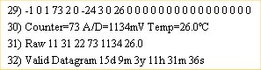
Raw data with time stamp and quantitative parameters is configured to desired outputs
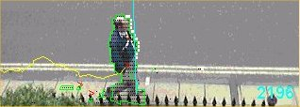
Pattern recognition in the outdoor environment captures people counts

Processing Captured Data

Our solution can be configured to send data to a local area network, through the internet to your servers, or through our own server where pre-configured data analysis tools are available. We pre-process data within our data gathering node to the specific needs of each application.

Data can be streamed from multiple sensors to develop a map of footfall activity across a location, whether that be a town centre or a retail store.

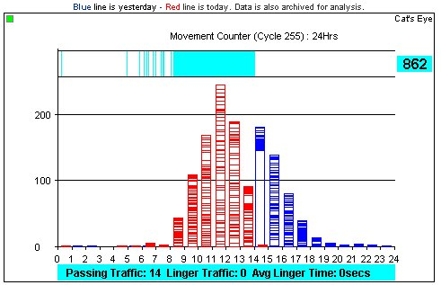

Real time data with specific characteristics highlighted graphically can give an “at a glance” view from a particular location.
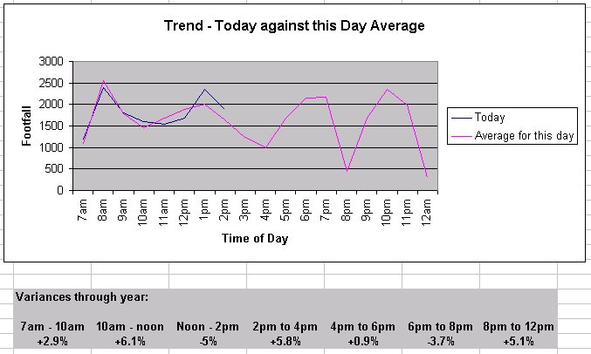

Processed and analysed data can be presented in a comparative form or as a trend analysis. Printed down reports and further database queries can be built into the configuration.

Multi-point to multi-user solutions

By using the internet as a communications channel we are able to provide multiple data streams that relay comparative data from multiple locations. Footfall data can then be delivered as a multi-user service. Opportunities for access by paid subscription are created by integrating our TurnStile log in module and TollWay payments system.



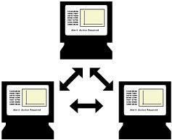
User group viewers
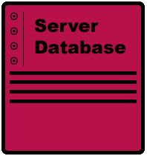
Server database

Internet

Local data node

Sensor cluster

Data delivered multi-point to multi-user can save costs on activity monitoring, marketing analysis, supply chain response, and other commercially important parameters. The CENS solution adds value by putting you in control over the activity going on in your areas of responsibility. The opportunity is there to enhance efficiency in your operations and increase your competitive advantage.

Installation

The equipment for a CENS network is modular. You can install one initial data gathering node and expand as your needs and finances demand. The equipment is compact, weighing less than 10 kilos and comes with simple mountings. We can arrange a full installation service for you to provide a turnkey solution.

Costs and revenue streams

CENS footfall networks are not expensive to develop. All you need to buy is your data-gathering node. Within the purchase price you obtain a licence to use our streaming technology to collect your footfall data. If your data stream is then channelled through our server you get a turnkey solution. We simply configure your data to your required specification and your presentation screens to your branding. We can present the data on your own web site or a dedicated area on our own servers. Once you have the data flowing you can turn this knowledge into a revenue opportunity by offering log in access to subscribers.

To find out more:

Main Highway – C.E.N.S Team
39 Southgate Street
Winchester SO23 9EH

Tel: 01962 870680

Fax: 01962 870699
E-mail: catseye@mainhighway.com
Web: www.mainhighway.com/catseye

